
University of Electronic Science and Technology
Of China

Postgraduate Studies Faculty

School of Eletronic Engineering

Major : Information and Communication Engineering

DIGITAL SIGNAL PROCCESSING

Discussion of the relationship among FT, DTFT, DFT, and Z-transform.

Prepared by: Ahmed Abdalla Ali Hamed
Student ID: 201314020104


Supervisor: Prof. Lin JingRan

UESTC - Chengdu - china
December 2013
1. Introduction
The analysis of real world signals is a fundamental problem for many engineers and scientists, especially for electrical engineers since almost every real world signal is changed into electrical signals by means of transducers, e.g., accelerometers in mechanical engineering, EEG electrodes and blood pressure probes in biomedical engineering, seismic transducers in Earth Sciences, antennas in electromagnetic and microphones in communication engineering, etc.

Traditional way of observing and analyzing signals is to view them in time domain. Baron Jean Baptiste Fourier, more than a century ago, showed that any waveform that exists in the real world can be represented (i.e., generated) by adding up sine waves. Since then, we have been able to build (break down) our real world time signal in terms of (into) these sine waves. It is shown that the combination of sine waves is unique; any real world signal can be represented by only one combination of sine waves.

The Fourier transform (FT) has been widely used in circuit analysis and synthesis, from filter design to signal processing, image reconstruction, stochastic modeling to non-destructive measurements. The FT has also been widely used in electromagnetic from antenna theory to radio wave propagation modeling, radar cross-section prediction to multi-sensor system system design. For example, the split-step parabolic equation method (which is nothing but the beam propagation method in optics) has been in use more than decades and is based on sequential FT operations between the spatial and wave number domains. Two and three dimensional propagation problems with non-flat realistic terrain profiles and inhomogeneous atmospheric variations above have been solved with this method successfully.

2. Fourier Transformation
The principle of a transform in engineering is to find a different representation of a signal under investigation. The FT is the most important transform widely used in electrical and computer (EC) engineering.

2.1 Fourier transform
The transformation from the time domain to the frequency domain (and back again) is based on the Fourier transform and its inverse, which are defined as
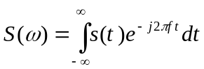 (1a)
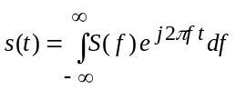 (1b)
Here, s (t), S (ω), and f are the time signal, the frequency signal and the frequency, respectively, and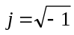. We, the physicists and engineers, sometimes prefer to write the transform in terms of angular frequency ω = 2π f, as
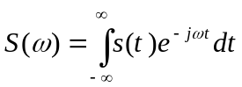 (2a)
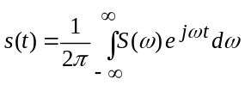 (2b)
Which, however, destroys the symmetry. To restore the symmetry of the transforms, the convention
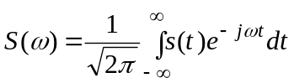 (3a)
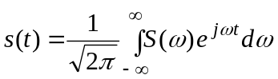 (3b)
Is sometimes used. The FT is valid for real or complex signals, and, in general, is a complex function of ω (or f).

The FT is valid for both periodic and non-periodic time signals that satisfy certain minimum conditions. Almost all real world signals easily satisfy these requirements (It should be noted that the Fourier series is a special case of the FT). Mathematically,

- FT is defined for continuous time signals.
- In order to do frequency analysis, the time signal must be observed infinitely.

Under these conditions, the FT defined above yields frequency behavior of a time signal at every frequency, with zero frequency resolution. Some functions and their FT are listed in Table 1.

Table 1: Some functions and their Fourier transforms
Time domain | Fourier transform
Rectangular window | Sinc function
Sinc function | Rectangular window
Constant function | Dirac Delta function
Dirac Delta function | Constant function
Dirac comb (Dirac train) | Dirac comb (Dirac train)
Cosine function | Two real even Delta function
Sine function | Two imaginary, odd Delta function
Exp function -{j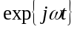} | One positive, real Delta function
Gauss function | Gauss function

2.2 Discrete–time Fourier transform (DTFT):
In , mathematics, the discrete-time Fourier transform (DTFT) is one of the specific forms of . Fourier analysis . As such, it transforms one function into another, which is called the frequency domain representation, or simply the "DTFT", of the original function (which is often a function in theTime domain) .But the DTFT requires an input function that is discrete Such inputs are often created by digitally sampling a continuous function, like a person's voice.
The DTFT frequency-domain representation is always a periodic function. Since one period of the function contains all of the unique information, it is sometimes convenient to say that the DTFT is a transform to a "finite" frequency-domain (the length of one period), rather than to the entire real line.

Frequency Domain Representation of Discrete-Time Signals and Systems

Discrete time Fourier Transform is a tool by which a time-domain sequence is mapped into a continuous function of a frequency variable. Because the DTFT is periodic the parent discrete-time sequence can be simply obtained by computing its Fourier Series representation.
Definition of the Forward Transform
Discrete-time Fourier transform 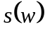 of a sequence x[n] is defined as:

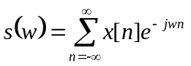 (4)
In general is a complex function of the real variable w .

2.3 Z transform
Definition
For a given sequence x[n], its z-transform X (z) is defined as
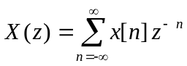 (5)

Where z is a complex variable can be expressed in form magnitude and angle (z=re^{jω)}.

Relation of Z transform and DTFT
Due to convergence condition, in many cases, the DTFT of a sequence may not exist; As a result, it is not possible to make use of such frequency-domain characterization in these cases.
We still need the frequency domain of this sequence in this case we use the Z transform to make the signal convergence.
DTFT is special case of Z transform when the amplitude of the complex z equal one (r=1).
The DTFT X (e^{jω}) of a sequence x[n] converges uniformly if and only if the ROC of the z-transform X (z) of x[n] includes the unit circle.
The existence of the DTFT does not always imply the existence of the z-transform.

2.4 Discrete Fourier transform (DFT)
To compute the Fourier transform numerically on a computer, discretization plus numerical integration are required. This is an approximation of the true (i.e., mathematical), analytically-defined FT in a synthetic (digital) environment, and is called discrete Fourier transformation (DFT). There are three difficulties with the numerical computation of the FT:
- Discretization (introduces periodicity in both the time and the frequency domains)
- Numerical integration (introduces numerical error, approximation)
- Finite time duration (introduces maximum frequency and resolution limitations)

The DFT of a continuous time signal sampled over the period of T, with a sampling rate of Δt can be given as
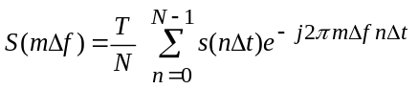 (5)
Where Δf=1/T, and, is valid at frequencies up to f_{max} = 1/(2Δt).

2.5 Fast Fourier Transform (FFT)
The Fast Fourier transform (FFT) is an algorithm for computing DFT, before which the DFT required excessive amount of computation time, particularly when high number of samples (N) was required. The FFT forces one further assumption, that N is an integer multiple of 2. This allows certain symmetries to occur reducing the number of calculations (especially multiplications) which have to be done.

2.6 Aliasing effect, Spectral Leakage and Scalloping Loss
As stated above, performing FT in a discrete environment introduces artificial effects. These are called aliasing effects, spectral leakage and scalloping loss.

It should know when dealing with discrete FT that:
- Multiplication in the time domain corresponds to a convolution in the frequency domain.
- The FT of an impulse train in the time domain is also an impulse train in the frequency domain with the frequency samples separated by T₀ = 1/f₀.
- The narrower the distance between impulses (T₀) in the time domain the wider the distance between impulses (f₀) in the frequency domain (and vice versa).
- The sampling rate must be greater than twice the highest frequency of the time record, i.e., 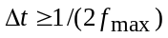 (Nyquist sampling criterion).
- Since time – bandwidth product is constant, narrow transients in the time domain possess wide bandwidths in the frequency domain.
- In the limit, the frequency spectrum of an impulse is constant and covers the whole frequency domain (that’s why an impulse response of a system is enough to find out the response of any arbitrary input).

If the sampling rate in the time domain is lower than the Nyquist rate aliasing occurs. Two signals are said to alias if the difference of their frequencies falls in the frequency range of interest, which is always generated in the process of sampling (aliasing is not always bad; it is called mixing or heterodyning in analog electronics, and is commonly used in tuning radios and TV channels). It should be noted that, although obeying Nyquist sampling criterion is sufficient to avoid aliasing, it does not give high quality display in time domain record. If a sinusoid existing in the time signal not bin-centered (i.e., if its frequency is not equal to any of the frequency samples) in the frequency domain spectral leakage occurs. In addition, there is a reduction in coherent gain if the frequency of the sinusoid differs in value from the frequency samples, which is termed scalloping loss.

2.7 Windowing and Window Functions
Using a finite-length discrete signal in the time domain in FT calculations is to apply a rectangular window to the infinite-length signal. This does not cause a problem with the transient signals which are time-bounded inside this window. But, what happens if a continuous time signal like a sine wave is of interest? If the length of the window (i.e., the time record of the signal) contains an integral number of cycles of the time signal, then, periodicity introduced by discretization makes the windowed signal exactly same as the original. In this case, the time signal is said to be periodic in the time record. On the other hand, there is a difficulty if the time signal is not periodic in the time record, especially at the edges of the record (i.e., window). If the DFT or FFT could be made to ignore the ends and concentrate on the middle of the time record, it is expected to get much closer to the correct signal spectrum in the frequency domain. This may be achieved by a multiplication by a function that is zero at the ends of the time record and large in the middle. This is known as windowing.

It should be realized that, the time record is tempered and perfect results shouldn’t be expected. For example, windowing reduces spectral leakage but does not totally eliminate it. It should also be noted that, windowing is introduced to force the time record to be zero at the ends; therefore transient signals which occur (starts and ends) inside this window do not require a window. They are called self-windowed signals, and examples are impulses, shock responses, noise bursts, sine bursts, etc.

Other window functions (as opposed to the natural rectangular window which has the narrowest main lobe, but the highest side lobe level) are used to obtain a compromise between a narrow main lobe (for high resolution) and low side lobes (for low spectral leakages). High frequency resolution provides accurate estimation of the frequency of an existing sinusoid and results in the separation of two sinusoids that are closely spaced in the frequency domain. Low spectral leakage improves the detectability of a weak sinusoid in the presence of a strong one that is not bin-centered. A few examples of common window functions are (n = 0, 1,2, … N-1)):

Rectangular: 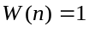 (6a)
Hanning: 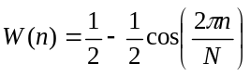 (6b)
Hamming: 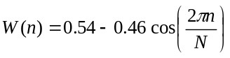 (6c)

All of these window functions act as a filter with a very rounded top. If a sinusoid in the time record is centered in the filter then it will be displayed accurately. Otherwise, the filter shape (i.e., the window) will attenuate the amplitude of the sinusoid (scalloping loss) by up to a few dB (15-20 %) when it falls midway between two consecutive discrete frequency samples. The solution of this problem is to choose a flat-top window function;
Flat-top: 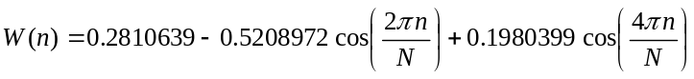 (7)
Which reduces the amplitude loss to a value less than 0.1 dB (1 %). However, this accuracy improvement does not come without its price; it widens the main lobe in the frequency domain response (i.e., a small degradation in frequency resolution). It should be remembered that there is always a pay off between accuracy and resolution when applying a window function.

3. Basic Discretization DFT and FFT Requirements

Mathematically defined Fourier transformation can be used to calculate the FT of a function at any frequency. There is no maximum frequency, or frequency resolution limit, since these are numerical FT restrictions. The maximum frequency in DFT or FFT depends on the sampling interval, and the frequency resolution is determined by the signal record length. That is N samples of a time signal recorded during a finite duration of T with a sampling period of Δt (N=T/Δt) can be transformed into N samples in the frequency domain between –f_{max} and +f_{max} according to
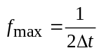, 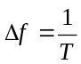. (8)
Since sampling interval and signal record lengths are finite in numerical computations in the computers maximum frequency and the resolution are also finite. This means

- Any frequency component 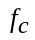beyond 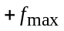 can not be observed in its actual frequency; instead it enters from left because of rotational symmetry and periodicity and appears at 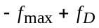where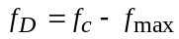.
- Similarly, any frequency component 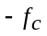beyond 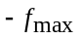 can not be observed in its actual frequency; instead it enters from left because of rotational symmetry and periodicity and appears at 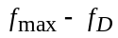where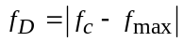.

4. Compare between the signal and the Fourier transform used
The table 2 bellow shows the Fourier transform of the signal and their characteristic.

Table 2 . Fourier transform of the signal.
Signal in time domain | Transformation used | Frequency domain | Notice
Continuous a periodical | Fourier transform (FT) | Continuous a periodical | Can’t use it in computer  Both time and frequency domain are continuous
Continuous periodical | Fourier series (FST) | Discrete | Can’t use it in computer  The time domain still continuous
Discrete | Discrete TIME Fourier (DTFT) | Periodical | Can’t use it in computer  The frequency domain still continuous
Discrete periodical | Discrete Fourier (DFT) | Discrete periodical | Can use the computer to manipulate it
Discrete periodical | Fast Fourier (FFT) | Discrete periodical | The same as above but used to reduce the time of processing.

Conclusion

Frequency analysis is one of the most important in issues digital signal processing. Using computers in numerical calculations means moving into a non-physical, synthetic environment. Numerically, discrete or fast Fourier transformations (DFT or FFT) are used to obtain the frequency contents of a time signal and these are totally different than mathematical definition of the Fourier transform.

